Lab 2: Containerization & Kubernetes Orchestration
Task 6: Docker Storage

1. Objective
Show that container-layer data is lost when a container is deleted, and that a named volume and a bind mount keep data permanently.

2. Data loss without a volume
The app was called 3 times (counter = 3). After deleting the container and starting a new one, the counter restarted at 1.
docker run -d --name lab2-novol -p 5101:5000 lab2-python-app:1.0
curl localhost:5101/ (x3)
docker rm -f lab2-novol
docker run -d --name lab2-novol -p 5101:5000 lab2-python-app:1.0
curl localhost:5101/

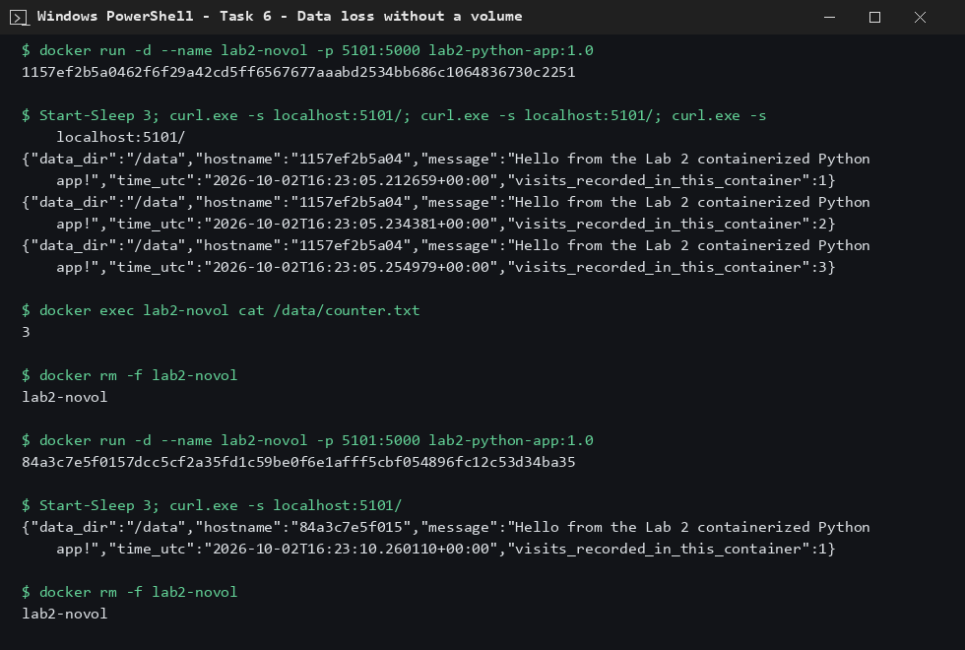
Figure 1: Counter resets to 1 after container deletion

3. Named volume and bind mount
With a named volume the counter continued (1, 2, then 3 in a new container). With a bind mount, counter.txt appears in the host folder storage-demo/bind-data.
docker volume create lab2-vol
docker run -d -v lab2-vol:/data -p 5102:5000 lab2-python-app:1.0
docker run -d -v "$PWD/storage-demo/bind-data:/data" -p 5103:5000 lab2-python-app:1.0

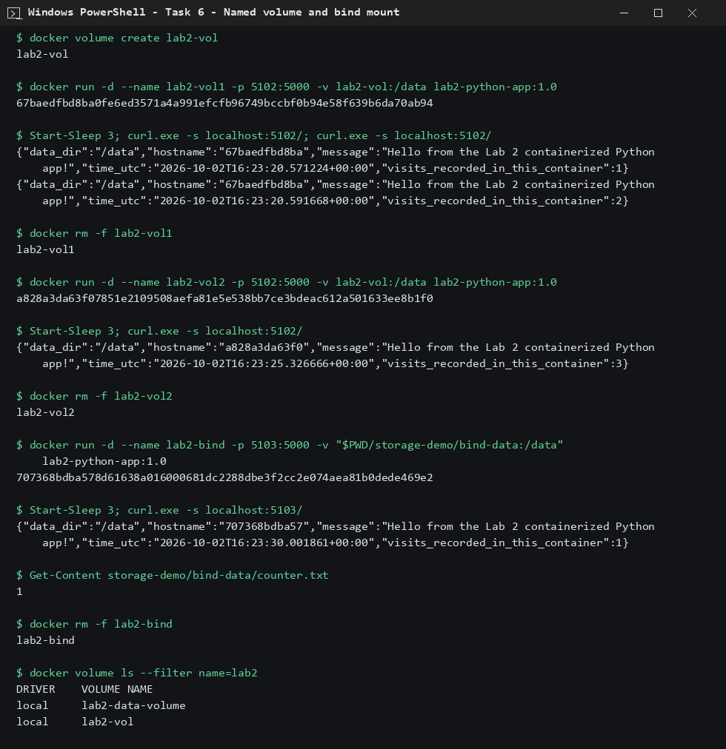
Figure 2: Named volume persists data; bind mount writes to the host folder

4. Conclusion
Data in the container layer is lost with the container, while named volumes and bind mounts keep data outside the container's lifecycle.

